Etiologies:

* Wilkins (2015)
  + Atherosclerosis (increasingly being recognized that 1 or more main visceral arteries need to be compromised)
  + Fibromuscular dysplasia
  + Vasculitis (umbrella over Takayusus arteritis, Beurgers arteritis)
  + Postoperative intimal hyperplasia
* Sreenarasimhaiah (2005)
  + Atherosclerotic occlusions and stenosis (mainly in CA and SMA) (90% of cases) (proximal segments)
  + Advanced diabetes or end-stage renal disease (diffuse atherosclerosis prevents development of collaterals)
  + MALS
  + Fibromuscular dysplasia
  + Takayusu’s arteritis
  + Thromboantiitis obliterans
  + Radiation-induced vascular injury
  + Mesenteric venous thrombus
    - Heritable disorders of coagulation
    - Pancreatitis
    - Inflammatory bowel disease
    - Cirrhosis
    - Portal hypertension
    - Paraneoplastic disorders
    - Postoperative states
    - Trauma

Someya:

Peak CA blood flow arrives approximately 10 minutes after a meal.

Peak SMA blood flow arrives approximately 45 minutes after a meal.

Problems with this study…

- Flow measured 20 min after meal. Not at peak SMA and CA flow is decreasing.

- Not all 3 main mesenteric vessels were measured.

- Categorization of CMI is based on flow measurements.

- Complete post-processing can take up to 40 minutes

Questions

- Can we look at pulsatility in SMV?

- Is MALS caused by inadequate collateral supply? Possibly pinching of a gastric artery along with CA? Perhaps “gastric steal” from small intestine? Pressure on celiac ganglia?

-

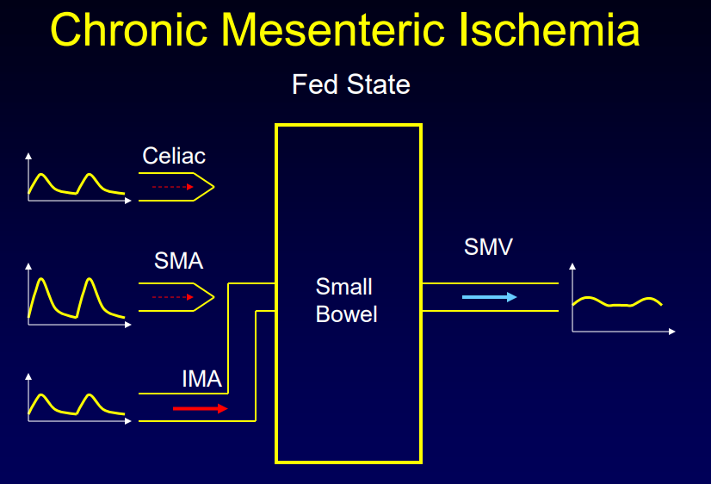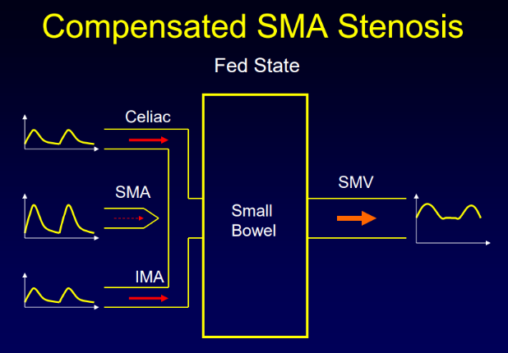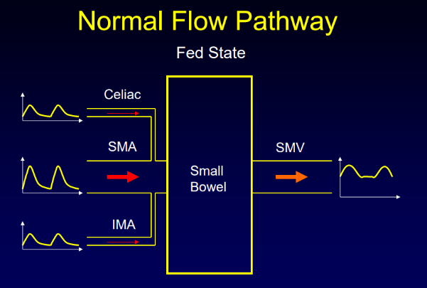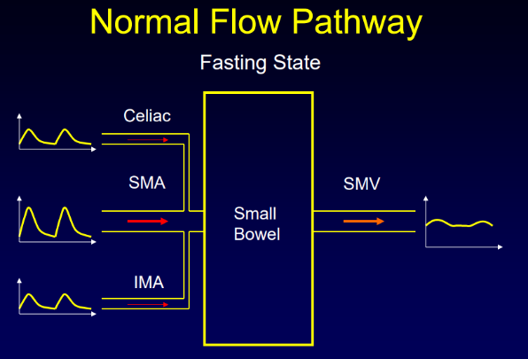

|  |  |  |  |  |  |  |
| --- | --- | --- | --- | --- | --- | --- |
| **Controls** | | | | | | |
| **Study** | Vessel | Fasting | 15-20 min | 30 min | 40-45 min | 50 min |
| **DJ Burkart (1993)** | SMA | 6.0+1.8 mL/min/kg |  |  |  |  |
| CA | 9.9+3.2 mL/min/kg |  |  |  |  |
| SMV | 5.7+2.0 mL/min/kg |  |  |  |  |
| PV | 13.7+1.8 mL/min/kg |  |  |  |  |
| **KC Li (1994)** | SMA | **217+25 mL/min** | **604+83 mL/min** | **868+101 mL/min** | **685+91 mL/min** |  |
| **KC Li (1995)** | SMA | 2.06+0.35 mL/min/kg |  | ~9.1 mL/min/kg |  |  |
| SMV | 3.57+0.71 mL/min/kg |  | ~15.3 mL/min/kg |  |  |
| **Burkart (1995)** | SMV | 4.6+0.9 mL/min/kg | 15.7+4.5 mL/min/kg |  | 11.5+4.5 mL/min/kg |  |
| PV | 14.9+4.7 mL/min/kg |  | 25.4+8.9 mL/min/kg |  | 20.6+7.6 mL/min/kg |
| **Roberts (2018)** | SMA | **446+170 mL/min**  5.97+3.15 mL/min/kg | **830+330 mL/min**  11.1+5.0 mL/min/kg |  |  |  |
| CA | **832+376 mL/min**  11.7+8.02 mL/min/kg | **782+331 mL/min**  11.0+7.0 mL/min/kg |  |  |  |
| SMV | **507+202 mL/min**  6.61+2.66 mL/min/kg | **1093+391 mL/min**  14.2+4.56 mL/min/kg |  |  |  |
| PV | **1070+350 mL/min**  14.1+5.57 mL/min/kg | **1587+472 mL/min**  20.6+5.91 mL/min/kg |  |  |  |

|  |  |  |  |  |  |
| --- | --- | --- | --- | --- | --- |
| **Ischemia** | | | | | |
| **Study** | Vessel | Fasting | 15-20 min | 30 min | 40-45 min |
| **KC Li (1994)** | SMA | **~160 mL/min** | **~-25 mL/min** | **~40 mL/min** | **~20 mL/min** |
| **KC Li (1995)** | SMA | 3.90+0.11 mL/min/kg |  | ~1.0 mL/min/kg |  |
| SMV | 6.17+1.57 mL/min/kg |  | ~8.3 mL/min/kg |  |
| **Burkart (1994)** | SMV | 4.9+1.6 mL/min/kg | 7.8+1.5 mL/min/kg |  | 7.8+3.0 mL/min/kg |
| PV | 13.2+3.1 mL/min/kg |  |  |  |
| **Roberts (2018)** | SMA | **481+262 mL/min**  7.59+3.12 mL/min/kg | **578+309 mL/min**  9.37+4.52 mL/min/kg |  |  |
| CA | **511+376 mL/min**  7.79+3.51 mL/min/kg | **539+417 mL/min**  8.17+3.96 mL/min/kg |  |  |
| SMV | **666+292 mL/min**  10.7+3.64 mL/min/kg | **902+389 mL/min**  15.5+8.60 mL/min/kg |  |  |
| PV | **1082+344 mL/min**  17.7+5.71 mL/min/kg | **1250+585 mL/min**  20.8+10.3 mL/min/kg |  |  |

|  |  |  |  |
| --- | --- | --- | --- |
| **Without Ischemia** | | | |
| **Study** | Vessel | Fasting | 15-20 min |
| **DJ Burkart (1995)** | SMV | 6.0+1.8 mL/min/kg | 17.9+4.3 mL/min/kg |
| PV | 16.4+2.7 mL/min/kg |  |

|  |  |  |  |  |  |  |
| --- | --- | --- | --- | --- | --- | --- |
| SCAo Measurements | | | | | | |
|  | Modality | Meal Volume (mL) | Energy Content (kCal) | Composition  (P/F/C) | BF Fasting (mL/min) | BF Peak (mL/min) |
| **Les** | MRI |  |  |  | 3072+618 |  |
| **Taylor** | MRI |  |  |  | 2900+600 |  |
| **Roberts** | MRI | 474 | 700 | 15/28/57 | 3603+705 | 4152+883 |

|  |  |  |  |  |  |  |
| --- | --- | --- | --- | --- | --- | --- |
| IRAo Measurements | | | | | | |
|  | Modality | Meal Volume (mL) | Energy Content (kCal) | Composition  (P/F/C) | BF Fasting (mL/min) | BF Peak (mL/min) |
| **Les** | MRI |  |  |  | 1050+326 |  |
| **Taylor** | MRI |  |  |  | 900+400 |  |
| **Roberts** | MRI | 474 | 700 | 15/28/57 | 1109+484 | 1030+541 |

|  |  |  |  |  |  |  |
| --- | --- | --- | --- | --- | --- | --- |
| SMA Measurements | | | | | | |
|  | Modality | Meal Volume (mL) | Energy Content (kCal) | Composition  (P/F/C) | BF Fasting (mL/min) | BF Peak (mL/min) |
| **Cooper** | US | Solid | 778 | 9/37/57 | 513+29* | 849+77* |
| **Qamar and Read** | US | 400 | 390 | 22/36/43 | 523+40* | 846+72* |
| **Sieber** | US |  |  |  | 443+38* |  |
| **Moneta** | US |  |  |  | 538+37* |  |
| **Someya** | US |  |  |  | 381+31* |  |
| **Sidery and Macdonald** | US | 520 | 478 | -/-/84 |  | 825 |
| **Sidery and Macdonald** | US | 585 | 717 | -/-/84 |  | 1189 |
| **Burkart** | MRI |  |  |  | ***6.0+1.8*** |  |
| **Li** | MRI | 240 | 220 | 15/28/57 | 217+25* | 868+101* |
| **Li** | MRI | 240 | 220 | 15/28/57 | ***2.06+0.35*** | ***~9.1*** |
| **Roberts** | MRI | 474 | 700 | 15/28/57 | 446+170  ***6.0+3.1*** | 830+330  ***11.1+5.0*** |

|  |  |  |  |  |  |  |
| --- | --- | --- | --- | --- | --- | --- |
| CA Measurements | | | | | | |
|  | Modality | Meal Volume (mL) | Energy Content (kCal) | Composition  (P/F/C) | BF Fasting (mL/min) | BF Peak (mL/min) |
| **Moneta** | US |  |  |  | 1083+75* |  |
| **Someya** | US |  |  |  | 456+60* |  |
| **Burkart** | MRI |  |  |  | ***9.9+3.2*** |  |
| **Roberts** | MRI | 474 | 700 | 15/28/57 | 839+363  ***11.8+7.9*** | 782+331  ***11.0+7.0*** |

|  |  |  |  |  |  |  |
| --- | --- | --- | --- | --- | --- | --- |
| PV Measurements | | | | | | |
|  | Modality | Meal Volume (mL) | Energy Content (kCal) | Composition  (P/F/C) | BF Fasting (mL/min) | BF Peak (mL/min) |
| **Cooper** | US | Solid | 778 | 9/37/57 | 791+89* | 1310+147* |
| **Brown** | US |  |  |  | 864+188 |  |
| **Moriyasu** | US |  |  |  | 889+284 |  |
| **Gaiana** | US | Solid | 1100 | 18/39/43 | 832+245 | 1312+433 |
| **Nishida** | US |  |  |  | 889+284 |  |
| **Burkart** | MRI |  |  |  | ***13.7+1.8*** |  |
| **Burkart** | MRI | 480 | 700 | 15/28/57 | ***14.9+4.7*** | ***25.4+8.9*** |
| **Roberts** | MRI | 474 | 700 | 15/28/57 | 1070+350  ***14.1+5.6*** | 1587+472  ***20.6+5.9*** |

|  |  |  |  |  |  |  |
| --- | --- | --- | --- | --- | --- | --- |
| SMV Measurements | | | | | | |
|  | Modality | Meal Volume (mL) | Energy Content (kCal) | Composition  (P/F/C) | BF Fasting (mL/min) | BF Peak (mL/min) |
| **Burkart** | MRI |  |  |  | ***5.7+2.0*** |  |
| **Li** | MRI | 240 | 220 | 15/28/57 | ***3.57+0.71*** | ***~15.3*** |
| **Burkart** | MRI | 480 | 700 | 15/28/57 | ***4.6+0.9*** | ***15.7+4.5*** |
| **Roberts** | MRI | 474 | 700 | 15/28/57 | 488+232  ***6.6+2.7*** | 444+149  ***14.2+4.6*** |

|  |  |  |  |  |  |  |
| --- | --- | --- | --- | --- | --- | --- |
| SV Measurements | | | | | | |
|  | Modality | Meal Volume (mL) | Energy Content (kCal) | Composition  (P/F/C) | BF Fasting (mL/min) | BF Peak (mL/min) |
| **Nishida** | US |  |  |  | 450+192 |  |
| **Roberts** | MRI | 474 | 700 | 15/28/57 | 488+232 | 444+149 |

|  |  |  |  |  |  |  |
| --- | --- | --- | --- | --- | --- | --- |
| LRA Measurements | | | | | | |
|  | Modality | Meal Volume (mL) | Energy Content (kCal) | Composition  (P/F/C) | BF Fasting (mL/min) | BF Peak (mL/min) |
| **Greene** | US |  |  |  | 396+98 |  |
| **Roberts** | MRI | 474 | 700 | 15/28/57 | 365+166 | 366+140 |

|  |  |  |  |  |  |  |
| --- | --- | --- | --- | --- | --- | --- |
| RRA Measurements | | | | | | |
|  | Modality | Meal Volume (mL) | Energy Content (kCal) | Composition  (P/F/C) | BF Fasting (mL/min) | BF Peak (mL/min) |
| **Greene** | US |  |  |  | 403+127 |  |
| **Roberts** | MRI | 474 | 700 | 15/28/57 | 361+112 | 387+132 |